**AI-BASED TOOL FOR PRELIMINARY DIAGNOSIS OF DERMATOLOGICAL MANIFESTATIONS**

*Submitted for partial fulfillment of the requirements*

*for the award of*

**BACHELOR OF TECHNOLOGY**

**in**

**COMPUTER SCIENCE ENGINEERING - ARTIFICIAL INTELLIGENCE & MACHINE LEARNING**

by

**Gopavarapu Hari Chandana** - **20BQ1A4220**

**Addanki Sandhya Grace** - **20BQ1A4201**

**Vemula Chenchu Naga Lakshmi** - **20BQ1A4262**

**Rekapalli John Blessing** - **20BQ1A4246**

Under the guidance of

**Byra Pardha Saradhi M.Tech**

**Assistant Professor**



**DEPARTMENT OF COMPUTER SCIENCE ENGINEERING - ARTIFICIAL INTELLIGENCE & MACHINE LEARNING**

**VASIREDDY VENKATADRI INSTITUTE OF TECHNOLOGY**

Permanently Affiliated to JNTU Kakinada, Approved by AICTE

Accredited by NAAC with ‘A’ Grade, ISO 9001:2008 Certified

NAMBUR (V), PEDAKAKANI (M), GUNTUR – 522 508

Tel no: 0863-2118036, url: www.vvitguntur.com

2023 - 2024

**VASIREDDY VENKATADRI INSTITUTE OF TECHNOLOGY**

Permanently Affiliated to JNTUK, Kakinada, Approved by AICTE

Accredited by NAAC with ‘A’ Grade, ISO 9001:20008 Certified

Nambur, Pedakakani (M), Guntur (Gt) -522508

**DEPARTMENT OF COMPUTER SCIENCE ENGINEERING - ARTIFICIAL INTELLIGENCE & MACHINE LEARNING**

**CERTIFICATE**

This is to certify that this **Project Report** is the bonafide work of **Ms. G. Hari Chandana,**

**Ms. A. Sandhya Grace, Ms. V. Ch. Naga Lakshmi, Mr. R. John Blessing**, bearing Reg. No. **20BQ1A4220, 20BQ1A4201, 20BQ1A4262, 20BQ1A4246** respectivelywho had carried out the project entitled **“AI-Based Tool for Preliminary Diagnosis of Dermatological Manifestations”** under our supervision.

**Project Guide Head of the Department**

(Byra Pardha Saradhi, Assistant Professor) (Dr. K. Suresh Babu, Professor)

**Submitted for Viva voce Examination held on ____________________________**

**Internal Examiner External Examiner**

**DECLARATION**

We, Ms. Gopavarapu Hari Chandana, Ms. Addanki Sandhya Grace, Ms. Vemula Chenchu Naga Lakshmi, Mr. Rekapalli John Blessing, hereby declare that the Project Report entitled **“AI-Based Tool for Preliminary Diagnosis of Dermatological Manifestations”** done by us under the guidance of Byra Pardha Saradhi, Assistant Professor, Computer Science Engineering at Vasireddy Venkatadri Institute of Technology is submitted for partial fulfillment of the requirements for the award of Bachelor of Technology in Computer Science Engineering – Artificial Intelligence & Machine Learning. The results embodied in this report have not been submitted to any other University for the award of any degree.

DATE :

PLACE : Nambur

SIGNATURE OF THE CANDIDATE (S)

G. Hari Chandana

A. Sandhya Grace

V. Naga Lakshmi

R. John Blessing

**ACKNOWLEDGEMENT**

We take this opportunity to express my deepest gratitude and appreciation to all those people who made this project work easier with words of encouragement, motivation, discipline, and faith by offering different places to look to expand my ideas and helped me towards the successful completion of this project work.

First and foremost, we express my deep gratitude to **Mr. Vasireddy Vidya Sagar**, Chairman, Vasireddy Venkatadri Institute of Technology for providing necessary facilities throughout the B.Tech programme.

We express my sincere thanks to **Dr. Y. Mallikarjuna Reddy**, Principal, Vasireddy Venkatadri Institute of Technology for his constant support and cooperation throughout the B.Tech programme.

We express my sincere gratitude to **Dr. K. Suresh Babu**, Professor & HOD, Computer Science Engineering – Artificial Intelligence & Machine Learning, Vasireddy Venkatadri Institute of Technology for his constant encouragement, motivation and faith by offering different places to look to expand my ideas.

We would like to express my sincere gratefulness to our Guide **Mr.** **Byra Pardha Saradhi**, Assistant Professor, CSEfor his insightful advice, motivating suggestions, invaluable guidance, help and support in successful completion of this project.

We would like to express our sincere heartfelt thanks to our Project Coordinator **Mr. N.** **Balayesu**, Assistant Professor, Computer Science Engineering - Artificial Intelligence and Machine Learning for his valuable advices, motivating suggestions, moral support, help and coordination among us in successful completion of this project.

We would like to take this opportunity to express my thanks to the **Teaching and Non-Teaching** Staff in the Department of Computer Science Engineering - Artificial Intelligence and Machine Learning, VVIT for their invaluable help and suppo

**Name (s) of Students**

**G. Hari Chandana**

**A. Sandhya Grace**

**V. Ch. Naga Lakshmi**

**R. John Blessing**

**TABLE OF CONTENTS**

**CH No Title Page No**

Contents i

List of Figures iv

List of Tables v

Nomenclature vi

Abstract vii

**1 INTRODUCTION 1**

1.1 Background and rationale for the study 1

1.2 Statement of the problem 2

1.3 Aims and objectives of the research 2

1.4 Research questions or hypotheses 3

1.4.1 Research Questions 4

1.4.2 Hypotheses 4

1.5 Scope and limitations of the study 5

1.6 Peculiarity of Project 5

1.7 Block Diagram 6

**2 LITERATURE SURVEY 7**

2.1 Dermatological treatments: Traditional to modern approaches 8

2.2 Technology in Dermatology: Lasers, surgery, innovations 8

2.3 AI aids treatment planning: Personalized, data-driven 9

2.4 Nanotechnology in skincare and diagnostics 10

2.5 Telemedicine in Dermatology: Remote Consultations,

Accessibility 10

2.6 Challenges in AI Implementation: Privacy, ethics, regulation 11

2.7 Future of Dermatology: Trends, breakthroughs, evolution 12

2.8 Conclusion 13

**3 PROPOSED SYSTEM 14**

3.1 Existing System 14

3.1.1 Disadvantages 14

3.2 Proposed System 15

3.2.1 Advantages 15

3.3 Methodology 16

3.3.1Description of the AI model development process 16

3.3.2 Data collection for skin image datasets 18

3.3.3 Details of the algorithm and software used 19

3.3.4 User role definitions and interactions 20

3.3.5 Ethical considerations and data privacy measures 21

3.4 System Requirements 22

3.4.1 Software Requirements 22

3.4.2 Hardware Requirements 22

3.5 System Design 22

3.5.1 Input Design 22

3.5.2 Output Design 23

3.6 UML Diagrams 24

3.6.1 Use Case Diagram 24

3.6.2 Class Diagram 25

3.6.3 Sequence Diagram 26

3.6.4 Collaboration Diagram 27

3.6.5 Activity Diagram 27

3.6.6 Component Diagram 28

3.6.7 Deployment Diagram 29

3.6.8 ER Diagram 29

3.6.9 DFD Diagram 30

**4 IMPLEMENTATION 32**

4.1 Deep Learning Algorithms 32

4.1.1 ResNet50 Model 32

4.1.2 VGG19 Model 33

4.1.3 Xception Model 33

4.2 Visual Studio Code 40

4.3 Python Flask Server 41

4.4 MYSQL 41

**5 RESULTS** **42**

**6 CONCLUSION AND FUTURE SCOPE** **44**

**7 REFERENCES**  **46**

**APPENDIX**

Conference Presentation Certificate **47**

Published Article in the Journal **48**

**LIST OF FIGURES**

**Figure No Figure Name Page No**

1.6 Block Diagram of Project 6

3.6.1 Use Case Diagram 25

3.6.2 Class Diagram 26

3.6.3 Sequence Diagram 26

3.6.4 Collaboration Diagram 27

3.6.5 Activity Diagram 28

3.6.6 Component Diagram 28

3.6.7 Deployment Diagram 29

3.6.8 ER Diagram 30

3.6.9 DFD Diagram 31

3.1 VGG19 Architecture 34

5.1 Home Page 42

5.2 User Registration and Authentication 42

5.3 Image Upload and Data Input 43

5.4 Diagnostic Report 46

**LIST OF TABLES**

**Table No Table Name Page No**

1 Disease Dataset Description 17

**NOMENCLATURE**

ML Machine Learning

DL Deep Learning

AI Artificial Intelligence

CNN Convolution Neural Network

PC Personal Computer

ResNet Residual Networks

VGG Visual Geometry Group

ER Entity Relationship

DFD Data Flow Diagram

**ABSTRACT**

The increasing prevalence of skin diseases and the shortage of dermatologists in many regions necessitate the development of innovative solutions to assist in the preliminary diagnosis of dermatological conditions. We present an AI-based tool designed to serve as an aid for patients, general practitioners, and dermatologists. This system leverages ResNet50, VGG19, and Xception Models architectures for the analysis of skin image datasets, providing a platform for the preliminary diagnosis of skin diseases.

Upon registration, users can access different functionalities based on their role: admin/owner, patient, or doctor. The admin can train the model with a skin image dataset, view registered users, and receive feedback. Patients can log in, upload skin images, and provide additional information such as age, gender, and condition duration. The system then classifies the disease, provides a description, suggests remedies, and assesses disease severity. It also recommends dermatologists based on the diagnosis, allowing patients to book appointments and view their past disease history.

Doctors can view their appointments and manage their profiles, enhancing the tool's utility for professional use. The system is designed to support both English and Telugu, broadening its accessibility. Through this AI-based diagnostic tool, we aim to bridge the gap in dermatological care by providing immediate, preliminary support, and facilitating effective patient-doctor interaction.

**Keywords:** Early diagnosis, Web Application, Deep Learning, Machine Learning, Diagnostic Report, Severity Assessment, Dermatologist Recommendations, Chat Functionality, Appointment Booking, Skin Health

**CHAPTER 1**

**INTRODUCTION**

Skin diseases have posed an enduring challenge to human health, casting a global shadow that affects millions and presents diagnostic intricacies persisting through the centuries. Traditional diagnostic approaches, primarily reliant on visual examinations by healthcare professionals, have indeed provided valuable insights into a spectrum of conditions affecting the skin, hair, and nails. However, these approaches have grappled with inherent limitations that extend beyond the confines of mere visual scrutiny. This research aims to develop an AI-based tool capable of providing preliminary diagnoses for dermatological conditions to improve the accessibility and efficiency of dermatological care. This aim is underpinned by several specific objectives: To investigate the applicability of ResNet50, VGG19, and Xception Models architectures in accurately classifying skin diseases from images. The study will assess the diagnostic accuracy of these AI models compared to traditional methods, aiming to match or surpass the benchmark set by human experts in recognizing and classifying various skin conditions. To design a user-friendly interface for patients and healthcare providers. The interface should allow easy submission of skin images and relevant clinical information by patients, and facilitate the review and management of diagnostic reports by healthcare professionals**.**

## **1.1 Background and rationale for the study**

The prevalence of dermatological diseases globally is a significant health concern, with skin conditions ranking fourth among the most common causes of human illness. The complexity of skin diseases, combined with a global scarcity of dermatologists, especially in remote and underserved areas, necessitates the development of accessible diagnostic support. This disparity in healthcare access has spurred interest in leveraging artificial intelligence (AI) to bridge the diagnostic gap.

The application of AI, particularly ResNet50, VGG19, and Xception, has shown promising results in image recognition tasks due to their ability to learn hierarchical representations. In dermatology, where visual inspection plays a pivotal role in diagnosis, such AI models can be trained to recognize and classify skin conditions from images with a level of precision that approaches that of trained professionals. This potential makes AI a valuable ally in preliminary skin disease diagnosis.

Moreover, the integration of AI into healthcare aligns with the digital transformation trends across industries, including telemedicine. By enabling preliminary diagnosis through AI, patients can receive timely guidance and dermatologists can prioritize cases effectively, optimizing the healthcare workflow.

This study aims to develop and assess an AI-based tool that can support preliminary dermatological diagnosis. It seeks to address the accessibility challenge by providing a multilingual platform, thereby catering to a diverse population. The rationale lies not only in the technological feasibility of such a tool but also in its potential to democratize health care, allowing for earlier interventions and better patient outcomes. This research will contribute to the ongoing discourse on AI in healthcare, with a specific focus on its practical application in dermatology.

## **1.2 Statement of the problem**

Despite advances in healthcare, there remains a significant gap in dermatological services, particularly in preliminary diagnosis. The deficit of dermatologists and the geographic limitations in accessing specialist care exacerbate the problem, leading to delayed diagnoses and treatments. This gap in service disproportionately affects rural and underserved communities, often resulting in worsened health outcomes.

The problem is twofold: firstly, there is an uneven distribution of dermatological expertise, and secondly, there is an increasing incidence of skin diseases globally. The need for an accessible, efficient, and accurate preliminary diagnostic process is critical. This study proposes to address these issues by developing an AI-based diagnostic tool that can provide immediate, preliminary assessments of dermatological conditions. The tool aims to alleviate the burden on the healthcare system by enabling triage and prioritization, potentially reducing wait times for patients and helping to distribute the workload more evenly across available dermatological services.

**1.3 Aims and objectives of the research**

The overarching aim of this research is to develop an AI-based tool capable of providing preliminary diagnoses for dermatological conditions to improve the accessibility and efficiency of dermatological care. This aim is underpinned by several specific objectives:

* To investigate the applicability of ResNet50, VGG19, and Xception architectures in accurately classifying skin diseases from images. The study will assess the diagnostic accuracy of these AI models compared to traditional methods, aiming to match or surpass the benchmark set by human experts in recognizing and classifying various skin conditions.
* To design a user-friendly interface for patients and healthcare providers. The interface should allow easy submission of skin images and relevant clinical information by patients, and facilitate the review and management of diagnostic reports by healthcare professionals.
* To ensure multilingual support for the tool to cater to a diverse user base. Recognizing the importance of inclusivity, the tool will provide support in English and Telugu, thereby serving a broader demographic and ensuring that language barriers do not impede access to dermatological care.
* To evaluate the impact of the AI tool on the preliminary diagnosis process in terms of speed, accuracy, and patient throughput. The objective is to measure how the tool affects the efficiency of the diagnostic process, the rate at which patients receive their preliminary diagnoses, and the overall satisfaction among users.
* To explore the potential of the AI tool in reducing the workload of dermatologists by enabling effective triage. The tool is expected to assist in identifying cases that require urgent attention, allowing for better resource allocation and management within healthcare systems.

By achieving these objectives, the research will contribute to reducing the current strain on dermatological services and improve patient care through timely and accurate preliminary diagnoses.

## **1.4 Research questions or hypotheses**

The study is guided by the following research questions and hypotheses:

### **1.4.1 Research Questions**

* How accurately can an AI-based tool, utilizing ResNet50, VGG19, and Xception architectures, classify dermatological conditions from skin images compared to current diagnostic methods?
  + This question investigates the potential of AI as a reliable tool for dermatological diagnosis and its comparative performance against traditional approaches.
* What is the user acceptability and usability of the AI-based dermatological diagnostic tool among patients and healthcare professionals?
  + This explores the design and interface of the tool and its acceptance by the target users, which is critical for its adoption in real-world settings.
* How does the introduction of a multilingual AI-based diagnostic tool impact the accessibility of dermatological care across different linguistic demographics?
  + This addresses the role of language support in democratizing access to healthcare services, particularly in regions with linguistic diversity.
* What effect does the AI diagnostic tool have on the efficiency of the dermatological diagnostic process and the patient care pathway?
  + This question assesses the impact of the AI tool on the healthcare system, focusing on the speed of diagnosis and the potential to improve patient management.

### **1.4.2 Hypotheses**

* The AI-based diagnostic tool will demonstrate comparable or superior accuracy in skin disease classification to that of general practitioners and will serve as a valuable preliminary diagnostic aid.
* The usability of the AI tool will be rated highly by both patients and healthcare professionals, indicating a positive user experience and a high level of acceptability.
* The provision of multilingual support within the AI tool will significantly increase the accessibility of dermatological care for non-English speaking populations.
* The implementation of the AI tool will lead to improved efficiency in the diagnostic process, characterized by reduced time to diagnosis and enhanced patient flow within dermatological services.
* These research questions and hypotheses are formulated to validate the effectiveness of the AI-based tool and its potential to enhance dermatological care delivery.

## **1.5 Scope and limitations of the study**

The scope of this study encompasses the design, development, and evaluation of an AI-based tool for the preliminary diagnosis of dermatological conditions. It includes the application of ResNet50, VGG19, and Xception architectures for image analysis, the development of a user interface for various stakeholders (patients and healthcare providers), and the integration of multilingual support to cater to a broader demographic.

The research is focused on assessing the accuracy of the AI tool in classifying skin diseases, its usability, and its impact on the accessibility and efficiency of dermatological care. The study will also explore the tool's potential to assist in the triage process within healthcare systems. Participants will involve a diverse group of users, including patients and dermatologists, to test the tool's functionality and gather feedback on its performance and user experience.

However, the study faces several limitations. Firstly, the accuracy of the AI tool is heavily dependent on the quality and diversity of the dataset used for model training. A dataset that lacks variety may not be representative of the wider population, which can limit the tool's effectiveness across different skin types and conditions.

Secondly, while the tool is designed to be multilingual, it will initially support only English and Telugu, which may not fully represent the linguistic needs of all potential users. Additionally, the research is limited by the extent of technological acceptance and digital literacy among its intended users, which can influence the adoption rate of the AI tool.

Finally, the evaluation of the tool's impact on healthcare efficiency will be measured within a limited timeframe, which may not capture long-term effects and benefits. This study will provide a foundation for future research, which could address these limitations through extended trials, broader linguistic support, and longitudinal studies on technology adoption in healthcare.

## **1.6 Peculiarity of the Project**

The singularity of this project lies in its pioneering approach to integrating artificial intelligence for the preliminary diagnosis of dermatological conditions. By utilizing cutting-edge ResNet50, VGG19, and Xception architectures, the project sets a precedent in the application of AI for skin disease classification, potentially revolutionizing the field of teledermatology. The tool stands out due to its multilingual capabilities, particularly its support for English and Telugu, making it one of the first in its domain to address linguistic barriers in healthcare access. This project is not merely an academic exercise but a stride toward practical healthcare solutions, aiming to democratize access to dermatological care for underserved populations and streamline the workflow for healthcare providers. The potential impact of this AI-based diagnostic tool on global health could mark a significant milestone in the way we approach and manage skin health, paving the way for more inclusive and efficient healthcare services.

## **1.7 Block Diagram**

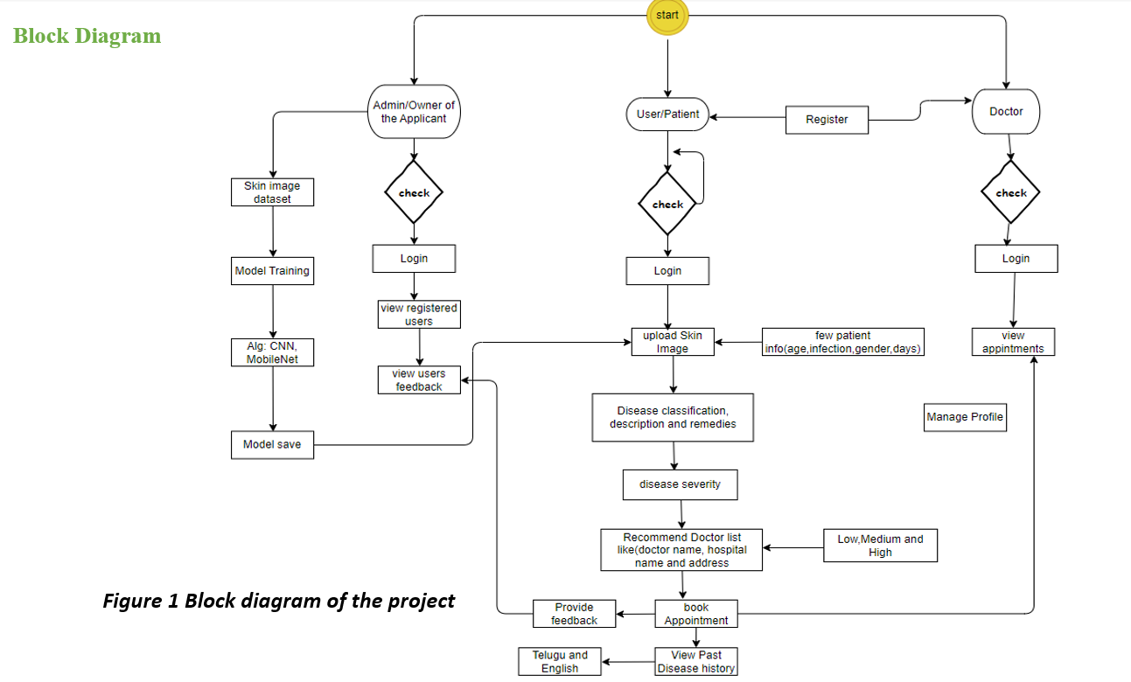

CHAPTER 2

**LITERATURE SURVEY**

Accurate diagnosis of skin diseases remains crucial for timely treatment and improved patient outcomes. Traditionally, dermatologists rely on visual examination and potentially biopsies. However, these methods can be subjective, time-consuming, and limited by access to specialists. Web-based technologies and deep learning algorithms offer promising advancements in automated skin disease detection, potentially improving accessibility, accuracy, and efficiency of diagnosis. This literature review examines recent research on web applications for skin disease detection using deep learning, exploring the potential benefits, limitations, and future directions of this technology, with a specific focus on informing the development of AISkinXpert. Deep Learning for Skin Disease Detection Several studies demonstrate the effectiveness of deep learning for skin disease classification using images [2]. [3]further explored convolutional neural networks (CNNs) for multiclass skin disease detection, achieving an accuracy of 87.4%. These studies highlight the potential of DL for accurate and automated skin disease analysis, laying the groundwork for web application development like AISkinXpert. Web Applications for Skin Disease Detection Existing Web applications offer several advantages over mobile apps for skin disease detection. They can leverage more powerful computing resources for complex algorithms, potentially leading to improved accuracy. Additionally, web interfaces can provide a more comprehensive user experience, allowing for detailed visualizations and educational resources. However, similar to mobile apps, concerns exist regarding data privacy, security, and the potential for misdiagnosis [4]. Robust algorithms, user education, and clear disclaimers are crucial for responsible development. Challenges remain in developing and deploying web applications for skin disease detection. The accuracy of DL models heavily relies on the quality and diversity of training datasets. Addressing potential biases within the data is essential to ensure generalizability across ethnicities and skin tones [5]. Furthermore, robust security measures are necessary to protect user data and comply with data privacy regulations. In conclusion, the literature survey has illuminated the evolving landscape of skin disease detection, emphasizing the transformative potential of deep learning within web applications.

The amalgamation of advanced algorithms and accessible interfaces is evident in studies by Esteva et al (2017) [2] and Yu et al. (2020) [5], providing a foundation upon which AISkinXpert can thrive. As we navigate the challenges of biased datasets, data privacy concerns, and the imperative for transparency, the outlined strategies for AISkinXpert development stand as a roadmap towards a responsible, accurate, and user-centric application.

## **2.1 Dermatological treatments: Traditional to modern approaches**

The evolution of dermatological treatments from traditional to modern approaches encapsulates a transition from empirical, experience-based practices to evidence-based, technologically-driven therapies. Historically, dermatology relied heavily on topical and herbal remedies, many rooted in ancient medicine, to alleviate skin ailments. Treatments were largely based on trial and error, with varying degrees of success and a limited understanding of underlying pathophysiological mechanisms.

The advent of modern medicine introduced a paradigm shift, characterized by rigorous scientific research and the development of targeted pharmaceutical treatments. The discovery of antibiotics and steroids, for example, revolutionized the treatment of infections and inflammatory conditions, respectively. Furthermore, the current era of dermatology is marked by advanced procedural interventions, such as laser therapy and photodynamic therapy, and the emergence of biologics for complex conditions like psoriasis and eczema. Additionally, the integration of AI for diagnostic and personalized treatment plans represents the cutting edge of dermatological practice, showcasing an innovative blend of technology and medicine to enhance patient outcomes.

## **2.2 Technology in Dermatology: Lasers, surgery, innovations**

The integration of technology in dermatology has led to groundbreaking advancements, with lasers, surgical techniques, and innovative treatments defining contemporary practice. Laser therapy, with its precision and specificity, has become a cornerstone for treating a myriad of conditions, from cosmetic concerns like wrinkles and scars to medical conditions such as port-wine stains and varicose veins.

The versatility of lasers allows for selective targeting of skin structures without damaging surrounding tissues, making treatments safer and recovery times faster.

Surgical dermatology has also seen significant advancements. Mohs surgery, a technique that meticulously removes skin cancer layer by layer, exemplifies the precision and improved patient outcomes afforded by technological progress. Surgeons can now ensure complete cancer removal while conserving as much healthy tissue as possible, thanks to enhanced imaging and microscopic control.

Innovation continues with the development of new drugs and biologics tailored to individual genetic profiles, facilitating personalized treatment plans. Wearable technology that monitors skin conditions in real-time and telemedicine platforms that enable remote consultations are also reshaping patient care. Artificial intelligence is at the forefront, with diagnostic algorithms becoming increasingly adept at identifying skin cancers and other dermatoses, potentially surpassing human accuracy. These technological triumphs reflect a modern dermatology landscape where the focus is not only on curing diseases but also on improving quality of life and patient care through innovative, tech-driven solutions.

## **2.3 AI aids treatment planning: Personalized, data-driven**

Artificial Intelligence (AI) is revolutionizing treatment planning in healthcare, offering a shift towards personalized, data-driven approaches. In this new paradigm, AI algorithms analyze vast datasets, including patient medical histories, genetic information, and treatment outcomes, to facilitate highly individualized treatment plans. This personalization is particularly crucial in complex diseases, where one-size-fits-all approaches are often ineffective.

AI's capacity to process and learn from big data enables the identification of patterns and correlations that might elude human analysis. This capability is transforming treatment strategies, allowing for the prediction of how different patients might respond to specific treatments. For instance, in oncology, AI can suggest the most effective drug combinations, taking into account the patient’s unique genetic makeup and the specific characteristics of their disease.

Moreover, AI assists in continuous monitoring and adjusting treatment plans based on real-time data. Wearable devices and health apps provide constant health data streams, which AI systems analyze to recommend modifications in treatment regimens, enhancing the efficacy and reducing potential side effects.

In essence, AI is not just an adjunct but a fundamental component in modern treatment planning. It brings an unprecedented level of precision to healthcare, enabling treatments that are tailored to individual patient profiles, thereby enhancing outcomes and ushering in a new era of personalized medicine.

## **2.4 Nanotechnology in skincare and diagnostics**

Nanotechnology is making significant strides in skincare and diagnostics, harnessing the power of materials at the nanoscale to revolutionize how we approach skin health. In skincare, nanotechnology is employed to improve the delivery of active ingredients. Nanoparticles can penetrate the skin more effectively than larger particles, allowing for deeper, more efficient delivery of nutrients and medications. This innovation is particularly beneficial in targeting specific skin layers and enhancing the effectiveness of anti-aging treatments, sunscreens, and topical medications for conditions like acne and psoriasis.

In diagnostics, nanotechnology has introduced a new realm of precision and sensitivity. Nanoscale biosensors, capable of detecting molecular changes in the skin, offer early diagnosis of skin conditions and skin cancers, often before they are visible to the naked eye. These biosensors can identify minute amounts of biomarkers, providing crucial information about skin health at a molecular level.

Furthermore, nanotechnology enables the development of smart, responsive skincare products. These products can adapt to the skin's changing conditions, such as pH and moisture levels, and release active ingredients accordingly. The implication of nanotechnology in skincare and diagnostics is vast, offering more personalized, effective, and proactive approaches to skin health and heralding a new era of high-tech skincare solutions.

## **2.5 Telemedicine in Dermatology: Remote consultations, accessibility**

Telemedicine has emerged as a transformative force in dermatology, profoundly enhancing accessibility and convenience through remote consultations. This digital shift allows patients to receive dermatological care from the comfort of their homes, breaking down geographical barriers and making specialist advice more readily available, especially in remote or underserved areas.

Through telemedicine, patients can easily share images of their skin conditions with dermatologists via secure platforms. This approach not only saves time but also expedites the diagnostic process. It's particularly beneficial for managing chronic conditions, postoperative follow-ups, and routine check-ups, reducing the need for in-person visits.

Moreover, telemedicine has proven invaluable in triaging cases, enabling dermatologists to prioritize patients who require urgent care while offering guidance and treatment plans for less severe cases remotely. This efficiency in patient management helps in optimizing resources and reducing wait times.

The impact of telemedicine in dermatology extends beyond patient consultations. It facilitates peer collaboration, allowing dermatologists to seek second opinions and discuss complex cases with specialists globally. In education, telemedicine serves as a tool for training and mentoring, broadening learning opportunities for medical professionals.

In essence, telemedicine in dermatology represents a significant advancement in healthcare delivery, offering a more accessible, efficient, and patient-centered approach to skincare, suitable for the modern digital age.

## **2.6 Challenges in AI Implementation: Privacy, ethics, regulation**

The implementation of AI in various sectors, including healthcare, faces several challenges, notably in privacy, ethics, and regulation. Privacy concerns are paramount as AI systems often require access to vast amounts of personal data to function effectively. Ensuring the confidentiality and security of this sensitive data against breaches is a significant concern. There's a risk of unauthorized access or misuse of personal health information, which could lead to privacy violations and a loss of public trust in AI systems.

Ethical considerations are equally critical. Decisions made by AI systems can significantly impact individuals' lives, raising questions about accountability and the potential biases in AI algorithms. Ensuring that AI systems make fair, unbiased decisions, and determining who is responsible when these systems make errors, are complex ethical issues that need addressing.

Regulation presents another challenge. The rapid development of AI technologies often outpaces the establishment of appropriate regulatory frameworks. There's a need for regulations that ensure the safe and effective use of AI, protecting users without stifling innovation. Balancing the potential benefits of AI with the risks it poses requires thoughtful and dynamic regulatory approaches that can adapt to the evolving nature of AI technologies. Addressing these challenges is crucial for the responsible and successful implementation of AI across various domains.

## **2.7 Future of Dermatology: Trends, breakthroughs, evolution**

The future of dermatology is poised for remarkable evolution, shaped by emerging trends and breakthroughs. One of the most significant trends is the increasing integration of technology, particularly artificial intelligence (AI) and telemedicine. AI is expected to revolutionize dermatological diagnostics and treatment planning, offering personalized, data-driven approaches. Telemedicine will continue to expand access to dermatological care, making it more convenient and efficient, especially in underserved areas.

Another promising area is the advancement in biologics and targeted therapies. These treatments, tailored to individual genetic profiles, are set to improve outcomes for chronic and complex skin conditions like psoriasis and eczema. Additionally, the role of nanotechnology in skin care and diagnostics is expanding, offering more precise and effective solutions for skin health.

The field will also see a growing focus on preventive care and early detection, especially in skin cancer. Innovations like wearable skin monitors and smart diagnostic tools will enable continuous monitoring of skin health, facilitating early intervention.

Moreover, the importance of holistic approaches to skin health, encompassing lifestyle, nutrition, and mental well-being, will gain more recognition. This comprehensive perspective on dermatology underscores the field's evolution from treating skin diseases to promoting overall skin health and wellness. These trends and breakthroughs collectively signal a future where dermatology is more personalized, accessible, and technologically advanced, promising better patient outcomes and a deeper understanding of skin health.

## **2.8 Conclusion**

In conclusion, this literature survey has provided a comprehensive overview of the dynamic and rapidly evolving field of dermatology, highlighting the significant strides made in integrating advanced technologies such as AI, telemedicine, and nanotechnology. The survey underscores the pivotal role of these innovations in transforming dermatological diagnostics, treatment, and patient care.

Artificial Intelligence, with its powerful data processing and analytical capabilities, is set to revolutionize dermatological diagnosis and personalized treatment planning. Telemedicine emerges as a key facilitator of increased accessibility and efficiency in dermatological care, bridging the gap between specialists and patients, especially in remote areas. Meanwhile, nanotechnology is paving the way for more effective and targeted skincare and diagnostic solutions.

However, this survey also acknowledges the challenges faced in the implementation of these technologies, including ethical, privacy, and regulatory concerns. Addressing these issues is crucial for the responsible integration of technology in dermatology.

Looking ahead, the future of dermatology appears promising, marked by ongoing innovation and a shift towards more personalized, preventive, and patient-centric care. The trends and breakthroughs discussed in this survey not only indicate a significant shift in how dermatological conditions are diagnosed and treated but also highlight the potential for improved patient outcomes and quality of life. As the field continues to evolve, it is clear that technology will play an increasingly central role in shaping the future of dermatology.

**CHAPTER 3**

**PROPOSED SYSTEM**

**3.1 Existing System**

The existing system in dermatological diagnostics that incorporates the Convolutional Neural Network (CNN) algorithm represents a significant technological advancement in the field. CNNs, a class of deep neural networks, are particularly adept at processing visual imagery, making them highly suitable for analyzing skin images. In the current setup, these algorithms are trained on large datasets of dermatological images, where they learn to identify patterns and features indicative of various skin conditions. The process typically involves inputting a skin image into the CNN, which then undergoes several layers of processing. Each layer extracts specific features from the image, with deeper layers identifying more complex patterns. The final output is a classification or diagnosis based on the features identified in the image. This system offers a more objective and consistent approach compared to traditional methods, which rely heavily on individual practitioner expertise.

By utilizing CNNs, the existing system can assist dermatologists in diagnosing a wide range of skin diseases more quickly and accurately, thereby enhancing patient care.

However, it is essential to note that this AI-based approach is generally used in conjunction with, rather than as a replacement for, the clinical judgment of healthcare professionals.

**3.1.1 Disadvantages**

1. Data Dependency: CNNs require large, diverse datasets for training; insufficient or biased data can lead to inaccurate or skewed diagnostic results.
2. Lack of Explain ability: CNNs operate as a "black box," making it difficult to understand how they arrive at specific diagnoses, impacting user trust.
3. Overfitting Risks: Without proper tuning, CNNs might overfit to training data, leading to poor performance on new, unseen images.
4. Resource Intensity: Training and running CNN models demand significant computational resources, which can be costly and limit accessibility in resource-constrained settings.
5. Complementary, Not Replacement: CNNs assist but don’t replace dermatologists' expertise; over-reliance on AI could overlook nuanced clinical insights and patient context.

**3.2 Proposed System**

AISkinXpert introduces a novel approach to dermatological diagnosis by combining the efficiency of Convolutional Neural Networks (CNNs), particularly the ResNet50 architecture, with an ensemble learning technique. This hybrid AI system aims to enhance the accuracy and versatility of skin disease diagnosis by leveraging the strengths of both CNNs and ensemble learning.

ResNet50, renowned for its success in addressing the vanishing gradient problem and its remarkable performance in image classification tasks, serves as the foundation of the proposed model. It efficiently extracts and processes intricate features from dermatological images, enabling the identification of key patterns indicative of various skin conditions.

Incorporating ensemble learning into the system adds a layer of robustness and adaptability. By aggregating the predictions of multiple models, each trained on different subsets of the dataset or employing different learning algorithms, the ensemble model can provide more accurate and reliable diagnoses. This approach mitigates the risk of overfitting and enhances the model's generalization capabilities, ensuring consistent performance across diverse patient demographics and skin conditions.

The proposed system leverages the complementary strengths of ResNet50 and ensemble learning to create a versatile and efficient diagnostic tool. By combining deep learning with ensemble techniques, AISkinXpert aims to achieve enhanced diagnostic accuracy, efficient processing, and improved patient outcomes.

**3.2.1 Advantages**

Enhanced Diagnostic Accuracy: The integration of ResNet50 and ensemble learning leverages spatial and ensemble-based data analysis, significantly enhancing the accuracy of skin condition diagnoses. By aggregating the predictions of multiple models, the system reduces the risk of misdiagnosis and ensures more reliable results.

Efficient Processing: ResNet50's lightweight architecture ensures fast image processing, making the system suitable for real-time applications and remote diagnostics. By efficiently extracting and processing spatial features from dermatological images, AISkinXpert minimizes processing time and enhances user experience.

Versatile Application: The hybrid model is adaptable to various skin types and conditions, enhancing its applicability across diverse patient demographics. By leveraging ensemble learning techniques, AISkinXpert can effectively handle complex and heterogeneous datasets, ensuring consistent performance across different skin conditions.

Comprehensive Understanding: The integration of ensemble learning enables the system to provide a comprehensive understanding of skin diseases, including their progression over time. By analyzing sequential data and aggregating predictions from multiple models, AISkinXpert offers insights into disease evolution, facilitating more effective treatment planning and patient care.

Improved Patient Outcomes: Accurate and timely diagnoses, coupled with comprehensive disease understanding, contribute to better treatment strategies and overall patient care. By enhancing diagnostic accuracy and providing insights into disease progression, AISkinXpert aims to improve patient outcomes and enhance healthcare delivery in dermatology.

**3.3 Methodology**

## **3.3.1 Description of the AI model development process**

Creating our dataset involved a careful and thorough process. We gathered data from various sources to cover a wide range of skin diseases. Important datasets like DermNet and SkinDataset were particularly helpful, providing us with diverse and extensive collections for our training and testing sets. These datasets form the backbone of our model training, ensuring it learns from a rich variety of skin conditions. The training dataset comprises a substantial collection of 15,500 images, carefully annotated to cover 23 distinct skin diseases. To validate the robustness of our model, a separate test set consisting of 4000 images was curated. This dataset includes challenging cases, ensuring the model's proficiency in handling various skin conditions. Each image was thoroughly annotated to provide the necessary ground truth for the training and testing phases.

Table-1: Disease Dataset description

|  |
| --- |
| **Disease Names** |
| 1. Acne and Rosacea Photos |
| 2. Actinic Keratosis Basal Cell Carcinoma and other Malignant Lesions |
| 3. Atopic Dermatitis Photos |
| 4. Bullous Disease Photos |
| 5. Cellulitis Impetigo and other Bacterial Infections |
| 6. Eczema Photos |
| 7. Exanthems and Drug Eruptions |
| 8. Hair Loss Photos Alopecia and other Hair Diseases |
| 9. Herpes HPV and other STDs Photos |
| 10. Light Diseases and Disorders of Pigmentation |
| 11. Lupus and other Connective Tissue diseases |
| 12. Melanoma Skin Cancer Nevi and Moles |
| 13. Nail Fungus and other Nail Disease |
| 14. Poison Ivy Photos and other Contact Dermatitis |
| 15. Psoriasis pictures Lichen Planus and related diseases |
| 16. Scabies Lyme Disease and other Infestations and Bites |
| 17. Seborrheic Keratoses and other Benign Tumors |
| 18. Tinea Ringworm Candidiasis and other Fungal Infections |
| 19. Urticaria Hives |
| 20. Systemic Disease |
| 21. Vascular Tumors |
| 22. Vasculitis Photos |
| 23. Warts Molluscum and other Viral Infections |

The methodology focuses on the AI model development process, which is a pivotal aspect of this research. The process begins with the selection of an appropriate AI architecture, for which ResNet50, VGG19 and Xception have been chosen due to their proven efficacy in image recognition tasks, particularly in medical imaging.

The development of the AI model involves several key steps:

* Data Collection: A comprehensive dataset of dermatological images is compiled. This dataset includes a wide range of skin conditions, ensuring diversity in terms of skin types, conditions, and severities. The images are sourced from medical databases and dermatology clinics, with patient consent and ethical approvals in place.
* Data Preprocessing: The collected images undergo preprocessing to enhance their quality and uniformity. This step includes resizing images, enhancing contrast, and normalizing pixel values. Anonymization of patient data is also performed to maintain privacy.
* Model Training and Validation: The ResNet50, VGG19 and Xception architecture is trained using the preprocessed dataset. The training involves feeding the model with images and their corresponding diagnoses to learn the patterns associated with different skin conditions. The model's performance is continually assessed through validation tests using a separate set of images not included in the training phase.
* Optimization and Testing: The model is fine-tuned to optimize its accuracy and reduce the likelihood of misdiagnosis. This involves adjusting parameters such as the learning rate and the number of layers in the network. Final testing is conducted with an independent dataset to evaluate the model's diagnostic accuracy and reliability.
* Implementation: The developed AI model is then integrated into a user-friendly interface, making it accessible for use by healthcare professionals and patients for preliminary skin condition diagnosis.

This methodology ensures a rigorous and systematic approach to developing a reliable and effective AI diagnostic tool for dermatological applications.

## **3.3.2 Data collection for skin image datasets**

The data collection phase for skin image datasets is a critical step in the development of the AI model. This process involves gathering a large and diverse set of skin images to train the AI system, ensuring it can accurately recognize and diagnose a wide range of dermatological conditions.

* Source Selection: The images are sourced from multiple channels to ensure diversity. These include dermatology clinics, hospitals, and online medical databases. Collaboration with dermatologists and healthcare institutions is essential for accessing clinically verified and high-quality images.
* Inclusivity and Diversity: To ensure the AI model's effectiveness across various skin types and conditions, the dataset includes images representing different ages, genders, skin tones, and types of skin diseases. This diversity is crucial for the model to be universally applicable and to reduce bias.
* Ethical Considerations and Consent: All data collection adheres to ethical standards. Patient consent is obtained for the use of their images in the dataset, ensuring privacy and confidentiality. Additionally, any identifying information is removed to maintain patient anonymity.
* Quality Control: The images are vetted for quality. Only clear, well-lit, and high-resolution images are included. This step is vital to ensure the accuracy of the model, as poor-quality images can lead to incorrect diagnoses.
* Data Annotation: Each image in the dataset is annotated with information about the diagnosis, severity, and any other relevant clinical information. This annotation is performed by experienced dermatologists to provide accurate labels for training the AI model.
* Data Augmentation: To enhance the robustness of the dataset, data augmentation techniques such as rotation, scaling, and flipping are used. This helps in creating a more comprehensive dataset, particularly when certain conditions or skin types are underrepresented.

Through these meticulous steps, the data collection process aims to create a robust and representative dataset, which is fundamental for the successful training and validation of the AI model in dermatological diagnostics.

## **3.3.3 Details of the algorithm and software used**

The AI model for dermatological diagnosis utilizes a sophisticated algorithm and software setup, central to its ability to accurately identify and classify skin conditions.

* Algorithm: The AISkinXpert model relies on the ResNet50 architecture as its cornerstone for image recognition and classification tasks. ResNet50, renowned for its effectiveness in handling intricate visual data, particularly suits the analysis of dermatological images due to its robust convolutional neural network (CNN) structure. By leveraging ResNet50's capabilities, AISkinXpert ensures accurate identification and classification of various skin conditions. Its deep layers enable the extraction of intricate features crucial for dermatological diagnosis, facilitating precise assessments. Through ResNet50's architecture, AISkinXpert optimizes the process of analyzing skin images, empowering healthcare professionals and patients with reliable diagnostic insights.
* Software Environment: The development and training of the model are carried out in Python, a programming language favored for its extensive libraries and frameworks supportive of AI and machine learning. Key libraries used include TensorFlow and Keras. TensorFlow provides a comprehensive, flexible ecosystem of tools and libraries for building and deploying machine learning models, while Keras offers a user-friendly interface for developing neural networks.
* Model Training and Validation: The training process involves feeding the ResNet50 with the dataset of annotated skin images. This training is done using a GPU-accelerated environment to handle the computational demands. The model undergoes rigorous validation using a separate dataset, ensuring the accuracy and reliability of its diagnostic capabilities.
* Optimization Tools: To enhance the model's performance, optimization tools like Adam optimizer and dropout techniques are employed. These tools help in fine-tuning the model, preventing overfitting, and ensuring it generalizes well to new, unseen data.

This combination of a robust algorithm and advanced software tools ensures that the AI model is not only accurate in its diagnostic capabilities but also efficient and scalable, making it suitable for practical applications in dermatological diagnostics.

## **3.3.4 User role definitions and interactions**

In the AI-based dermatological diagnostic tool, distinct user roles are defined to facilitate specific interactions tailored to the needs of each user group. These roles include Admin/Owner, Patients, and Doctors, each with unique functionalities and interfaces within the system.

* Admin/Owner: This role is primarily responsible for overseeing the system's operation. The admin can manage and train the AI model with new data, ensuring its continuous improvement. They are also tasked with monitoring user activity, maintaining data security, and ensuring the smooth functioning of the system. Feedback collection and response, system updates, and user support are other key responsibilities.
* Patients: Patients can register and log into the system to access its diagnostic features. They can upload images of their skin conditions along with relevant information such as symptom duration, location, and personal health history. The AI tool analyzes this information and provides a preliminary diagnosis, along with suggestions for treatment or advice to seek professional care. Patients also have the option to schedule appointments with dermatologists through the system.
* Doctors: Dermatologists or general practitioners using the system can access patient-submitted cases, review AI-generated diagnoses, and provide professional insights. They can manage their profiles, view their appointment schedules, and use the platform for patient communication and follow-up. This role allows doctors to prioritize urgent cases and manage their patient load more effectively.

Each role is designed to interact seamlessly within the system, ensuring a user-friendly experience that enhances the utility and efficiency of the dermatological diagnostic process for all parties involved.

## **3.3.5 Ethical considerations and data privacy measures**

Ethical considerations and data privacy are paramount in the development and deployment of the AI-based dermatological diagnostic tool. These aspects are meticulously addressed to ensure the responsible handling of sensitive patient information and to uphold ethical standards in AI applications.

* Patient Consent and Anonymity: Inherent in the data collection process is the need for explicit patient consent. Patients are informed about the use of their data, its purpose, and the potential benefits and risks. Once consent is obtained, strict measures are taken to anonymize the data. All personally identifiable information is removed to ensure patient privacy and confidentiality.
* Data Security: Robust data security protocols are implemented to safeguard against unauthorized access, data breaches, and cyber threats. This includes the use of encryption for data storage and transmission, secure authentication mechanisms for system access, and regular security audits to identify and rectify potential vulnerabilities.
* Bias and Fairness: Special attention is given to avoid biases in the AI model, which could lead to unequal treatment of patients based on race, gender, or skin type. The dataset used for training the AI model is diverse and representative, ensuring the tool's effectiveness and fairness across different demographics.
* Compliance with Regulations: The system adheres to relevant healthcare regulations and data protection laws, such as HIPAA in the United States or GDPR in Europe. This compliance ensures that the tool meets legal standards for data handling and patient privacy.
* Transparency and Accountability: The tool maintains transparency in its AI-driven decisions, providing explanations for its diagnostic suggestions. This aspect is crucial for building trust among users and for accountability in case of any errors or misdiagnoses.

By addressing these ethical considerations and data privacy measures, the project upholds high standards of integrity and respect for patient rights, ensuring that the AI tool is not only effective but also ethically sound and secure.

**3.4 System Requirements**

**3.4.1 Software Requirements**

Software’s : Python 3.6 or high version

IDE : Visual Studio Code

Framework : Flask

**3.4.1 Hardware Requirements**

Operating system : Windows 7 or 7+

RAM : 8 GB

Hard disc or SSD : More than 500 GB

Processor : Intel 3rd generation or high or Ryzen with 8 GB Ram

**3.5 System Design**

**3.5.1 Input Design**

In an information system, input is the raw data that is processed to produce output. During the input design, the developers must consider the input devices such as PC, MICR, OMR, etc.

Therefore, the quality of the system input determines the quality of the system output. Well-designed input forms and screens have the following properties −

* It should serve specific purposes effectively such as storing, recording, and retrieving the information.
* It ensures proper completion with accuracy.
* It should be easy to fill and straightforward.
* It should focus on the user’s attention, consistency, and simplicity.
* All these objectives are obtained using the knowledge of basic design principles regarding −
  + What are the inputs needed for the system?
  + How end users respond to different elements of forms and screens.

**Objectives for Input Design:**

The objectives of input design are −

* To design data entry and input procedures
* To reduce input volume
* To design source documents for data capture or devise other data capture methods
* To design input data records, data entry screens, user interface screens, etc.
* To use validation checks and develop effective input controls.

**3.5.2 Output Design**

The design of output is the most important task of any system. During output design, developers identify the type of outputs needed and consider the necessary output controls and prototype report layouts.

**Objectives of Output Design:**

The objectives of input design are:

* To develop an output design that serves the intended purpose and eliminates the production of unwanted output.
* To develop the output design that meets the end user’s requirements.
* To deliver the appropriate quantity of output.
* To form the output in the appropriate format and direct it to the right person.
* To make the output available on time for making good decisions.

**3.6 UML Diagrams**

UML stands for Unified Modelling Language. UML is a standardized general-purpose modeling language in the field of object-oriented software engineering. The standard is managed and was created by, the Object Management Group.

The goal is for UML to become a common language for creating models of object-oriented computer software. In its current form, UML is comprised of two major components: a Meta-model and a notation. In the future, some form of method or process may also be added to; or associated with, UML.

The Unified Modelling Language is a standard language for specifying, Visualization, Constructing, and documenting the artifacts of software systems, as well as for business modeling and other non-software systems.

The UML represents a collection of best engineering practices that have proven successful in the modeling of large and complex systems.

UML is a very important part of developing object-oriented software and the software development process. The UML uses mostly graphical notations to express the design of software projects.

**GOALS:** The Primary goals in the design of the UML are as follows:

1. Provide users with a ready-to-use, expressive visual modeling Language so that they can develop and exchange meaningful models.
2. Provide extensibility and specialization mechanisms to extend the core concepts.
3. Be independent of particular programming languages and development process.
4. Provide a formal basis for understanding the modeling language.
5. Encourage the growth of the OO tools market.
6. Support higher-level development concepts such as collaborations, frameworks, patterns, and components.
7. Integrate best practices.
   * 1. **Use Case Diagram**

A use-case diagram in the Unified Modeling Language (UML) is a type of behavioral diagram defined by and created from a Use-case analysis.

Its purpose is to present a graphical overview of the functionality provided by a system in terms of actors, their goals (represented as use cases), and any dependencies between those use cases.

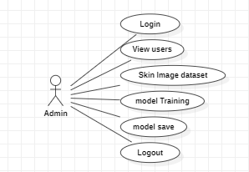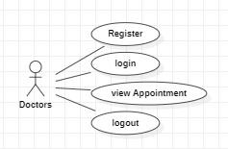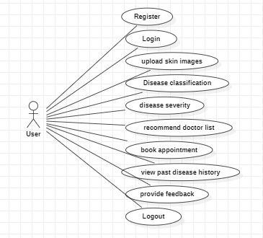The main purpose of a use case diagram is to show what system functions are performed for which actor. The roles of the actors in the system can be depicted system can be depicted.

**Figure 3.6.1 Use case diagram**

* + 1. **Class Diagram**

In software engineering, a class diagram in the Unified Modeling Language (UML) is a type of static structure diagram that describes the structure of a system by showing the system's classes, attributes, operations (or methods), and the relationships among the classes. It explains which class contains information.

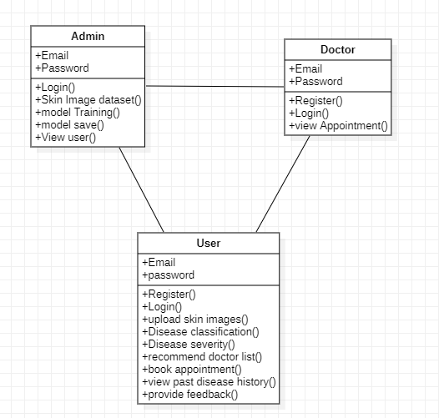

**Figure 3.6.2 Class diagram**

**3.6.3 Sequence Diagram**

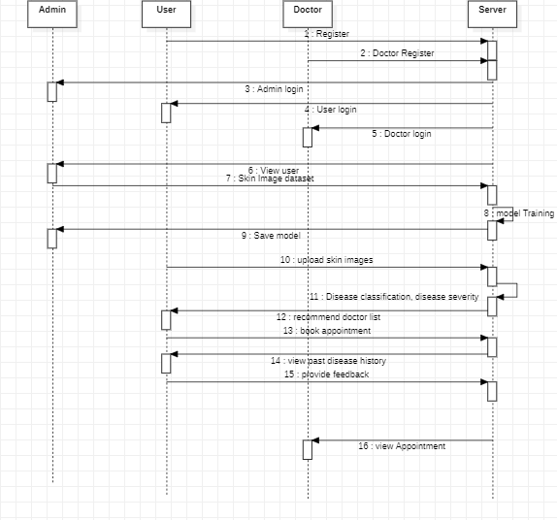

**Figure 3.6.3 Sequence Diagram**

A sequence diagram in Unified Modeling Language (UML) is a kind of interaction diagram that shows how processes operate with one another and in what order. It is a construct of a Message Sequence Chart. Sequence diagrams are sometimes called event diagrams, event scenarios, and timing diagrams.

* + 1. **Collaboration Diagram**

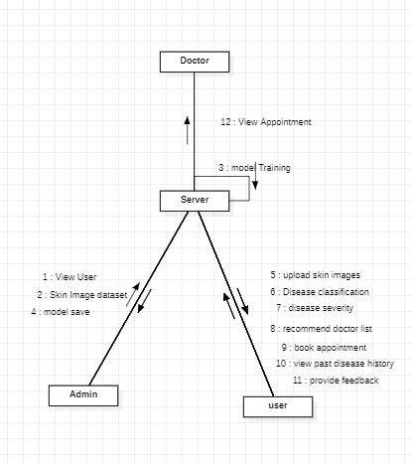In the collaboration diagram, the method call sequence is indicated by some numbering technique as shown below. The number indicates how the methods are called one after another. We have taken the same order management system to describe the collaboration diagram. The method calls are similar to that of a sequence diagram. But the difference is that the sequence diagram does not describe the object organization whereas the collaboration diagram shows the object organization.

**Figure 3.6.4 Collaboration Diagram**

* + 1. **Activity Diagram**

Activity diagrams are graphical representations of workflows of stepwise activities and actions with support for choice, iteration and concurrency. In the Unified Modelling Language, activity diagrams can be used to describe the business and operational step-by-step workflows of components in a system. An activity diagram shows the overall flow of control.

**Figure 3.6.5 Activity Diagram**

* + 1. 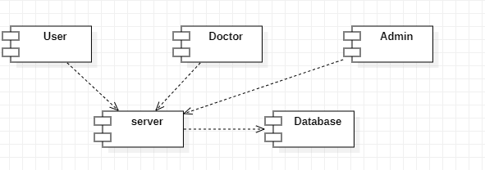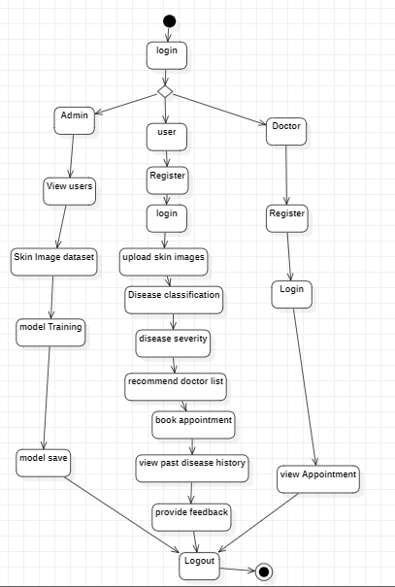**Component Diagram**

**Figure 3.6.6 Component Diagram**

A component diagram, also known as a UML component diagram, describes the organization and wiring of the physical **c**omponents in a system. Component diagrams are often drawn to help model implementation details and double-check that every aspect of the system's required function is covered by planned development.

* + 1. **Deployment Diagram**

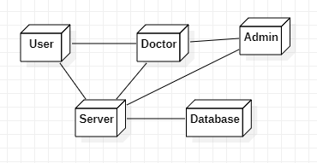The deployment diagram represents the deployment view of a system. It is related to the component diagram. Because the components are deployed using the deployment diagrams. A deployment diagram consists of nodes. Nodes are nothing but physical hardware used to deploy the application.

**Figure 3.6.7 Deployment Diagram**

### **3.6.8** **ER Diagram**

An Entity–relationship model (ER model) describes the structure of a database with the help of a diagram, which is known as an Entity Relationship Diagram (ER Diagram). An ER model is a design or blueprint of a database that can later be implemented as a database. The main components of the E-R model are the entity set and relationship set.

An ER diagram shows the relationship among entity sets. An entity set is a group of similar entities and these entities can have attributes. In terms of DBMS, an entity is a table or attribute of a table in the database, so by showing the relationship among tables and their attributes, ER diagram shows the complete logical structure of a database. Let’s have a look at a simple ER diagram to understand this concept.

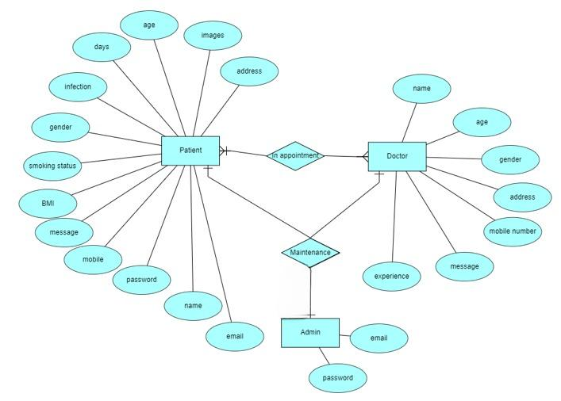

**Figure 3.6.8 ER Diagram**

* + 1. **DFD Diagram**

A Data Flow Diagram (DFD) is a traditional way to visualize the information flows within a system. A neat and clear DFD can depict a good amount of the system requirements graphically. It can be manual, automated, or a combination of both. It shows how information enters and leaves the system, what changes the information and where information is stored. The purpose of a DFD is to show the scope and boundaries of a system as a whole. It may be used as a communications tool between a systems analyst and any person who plays a part in the system that acts as the starting point for redesigning a system.

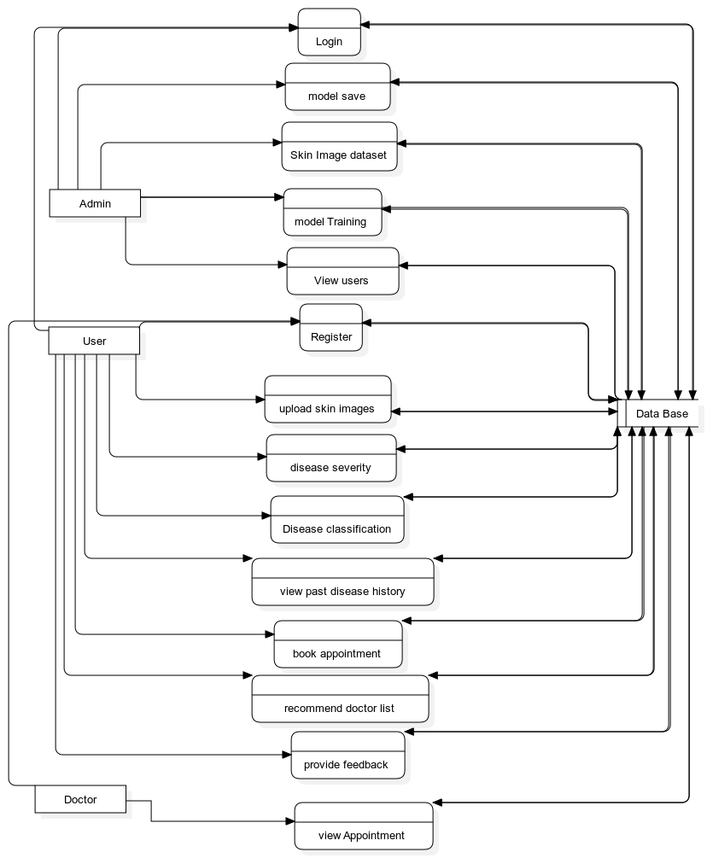

**Figure 3.6.9 DFD Diagram**

**CHAPTER 4**

**IMPLEMENTATION**

**4.1 Deep Learning Algorithms**

**4.1.1 ResNet Model**

ResNet50, a groundbreaking deep learning architecture, was introduced in their 2016 paper titled "Deep Residual Learning for Image Recognition". This architecture addresses challenges associated with training very deep neural networks, such as the vanishing gradient and degradation problems. As neural networks grow deeper, issues arise, including the vanishing gradient problem and the degradation problem, where adding more layers unexpectedly increases training error. Traditional networks become challenging to optimize and train as their depth increases.

ResNet50, which stands for Residual Network with 50 layers, represents a pivotal solution to the vanishing gradient problem. It introduces residual connections, allowing the network to learn residual functions instead of directly learning desired mappings. This innovation facilitates the training of exceptionally deep networks, making ResNet50 well-suited for complex image recognition tasks. ResNet50 has demonstrated remarkable performance in various computer vision benchmarks and competitions, becoming widely adopted in deep learning applications.

This powerful deep-learning model features 24 layers and is commonly used for image classification tasks. The architecture utilizes residual blocks for effective training, beginning with a standard convolutional layer followed by batch normalization and rectified linear unit (ReLU) activation. Max pooling is employed for spatial dimension downsampling, enhancing the model's ability to capture hierarchical features.

ResNet50's key innovation lies in its use of shortcut connections, or skip connections, within residual blocks. These connections facilitate the flow of information through the network by bypassing certain layers, mitigating the vanishing gradient problem and enabling the training of very deep networks.

As the network progresses, spatial dimensions decrease, and the number of filters increases, capturing increasingly abstract and high-level features. The model incorporates global average pooling to aggregate spatial information, reducing parameters before transitioning to dense layers for classification.

The architecture concludes with two fully connected layers – the first with 512 units and ReLU activation, and the second with 23 units, corresponding to the number of output classes. ResNet50 boasts a substantial parameter count of 24,648,599, with 1,060,887 trainable parameters, showcasing efficiency in training. The non-trainable parameters primarily consist of skip connections, crucial for capturing intricate features and patterns, making ResNet50 a prominent choice in various computer vision applications, including AISkinXpert.

**4.1.2 Xception Model**

The Xception model, developed by [6], is a highly efficient deep convolutional neural network architecture renowned for its outstanding performance in image classification tasks. Its unique design, featuring extreme depth, makes it a notable choice in computer vision applications, particularly for image recognition and feature extraction.

Scientists and researchers leverage the Xception model across various domains due to its intricate architecture. The model begins with an input layer configured for processing 224x224 pixel images with three RGB color channels. Unfolding through 36 feature extraction blocks, labeled block1 to block14, the model employs separable convolution layers for efficient feature extraction, enabling it to discern intricate patterns in the data.

A crucial transition occurs with the Global Average Pooling layer, strategically placed to condense the tensor's spatial dimensions into a concise 1x1 feature vector. This transformation sets the stage for fully connected layers, enriched with dense connections and fortified by batch normalization. At the heart of the classification task, the final dense layer produces an output shape of (None, 3), highlighting the model's proficiency in handling three distinct classes.

The architectural magnificence of Xception extends to its parameter configuration, totaling 22,053,931 parameters. Of these, 1,186,819 are trainable, while 20,867,112 remain non-trainable, with their weights deliberately frozen during training. This nuanced interplay of architecture and parameters equips the Xception model to navigate the complexities of diverse datasets, establishing it as a cornerstone in the domain of image classification and feature extraction

**4.1.3 VGG Model**

VGG19, a variant of the VGG (Visual Geometry Group) architecture, is a deep convolutional neural network designed for image classification. It was introduced by Karen Simonyan and Andrew Zisserman in their 2014 paper "Very Deep Convolutional Networks for Large-Scale Image Recognition". VGG19 is renowned for its simplicity and uniform architecture, consisting of multiple convolutional and pooling layers.

VGG19 is composed of 16 convolutional layers, grouped into five convolutional blocks, followed by three fully connected layers. The convolutional blocks are labeled as "block1" through "block5." Each block consists of multiple convolutional layers, followed by a max-pooling layer to reduce spatial dimensions.

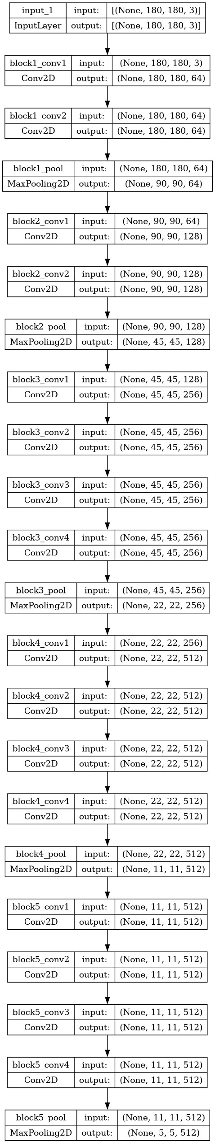

In our study, we rigorously evaluated three prominent deep learning models—Xception, VGG19, and ResNet50—each pre-trained on extensive image datasets. The primary objective was to discern the model that best suited our image classification task. These models underwent comprehensive training, fine-tuning their pre-trained weights on our dataset and incorporating data augmentation techniques to enhance generalization capabilities. Extensive hyperparameter tuning was conducted, optimizing parameters such as learning rates and batch sizes for optimal performance. Following a robust validation process on a separate dataset, the ResNet50 model consistently demonstrated superior accuracy, achieving an impressive 92%. Thus, based on empirical evidence, we selected ResNet50 as the most effective architecture for our specific dataset and classification task.

**Code:**

import numpy as np

import os

import cv2

import random

import matplotlib.pyplot as pl

from tensorflow.keras.applications import ResNet50

from tensorflow.keras.applications.resnet50 import preprocess_input

from tensorflow.keras.models import Model

from tensorflow.keras.layers import GlobalAveragePooling2D, Dense

data_path = '/kaggle/input/dermnet/train'

train_data = []

val_data = []

for folder in os.listdir(data_path):

folder_path = os.path.join(data_path, folder)

file = os.listdir(folder_path)

num_train = int(0.8 * len(file))

files_train = random.sample(file, num_train)

files_val = list(set(file) - set(files_train))

for file in files_train:

file_path = os.path.join(folder_path, file)

img = cv2.imread(file_path)

img = cv2.resize(img, (224,224))

train_data.append((img, folder))

for file in files_val:

file_path = os.path.join(folder_path, file)

img = cv2.imread(file_path)

img = cv2.resize(img, (224,224))

val_data.append((img, folder))

fig, axes = plt.subplots(2, 4, figsize=(10, 5))

plt.suptitle('LABELS OF EACH IMAGE')

for (img, label), ax in zip(random.sample(train_data, 8), axes.flatten()):

ax.xaxis.set_ticklabels([])

ax.yaxis.set_ticklabels([])

ax.grid(True)

ax.set_title(label)

ax.imshow(cv2.cvtColor(img, cv2.COLOR_BGR2RGB) )

plt.show()

base_model = ResNet50(weights='imagenet', include_top=False, input_shape=(224, 224, 3))

base_model.trainable = False

num_classes = 23

x = GlobalAveragePooling2D()(base_model.output)

x = Dense(512, activation='relu')(x)

predictions = Dense(num_classes, activation='softmax')(x)

model = Model(inputs=base_model.input, outputs=predictions)

model.compile(optimizer='adam', loss='categorical_crossentropy', metrics=['accuracy'])

from sklearn.preprocessing import LabelEncoder

from tensorflow.keras.utils import to_categorical

X_train, y_train = zip(*train_data)

X_val, y_val = zip(*val_data)

X_train = preprocess_input(np.array(X_train))

X_val = preprocess_input(np.array(X_val))

le = LabelEncoder()

y_train_encoded = le.fit_transform(y_train)

y_val_encoded = le.transform(y_val)

y_train_one_hot = to_categorical(y_train_encoded, num_classes)

y_val_one_hot = to_categorical(y_val_encoded, num_classes)

from keras.callbacks import ModelCheckpoint, EarlyStopping

custom_early_stopping = EarlyStopping(

monitor='val_loss',

patience=10,

min_delta=0.001,

mode='min'

)

EPOCHS = 25

BATCH_SIZE = 64

history = model.fit(X_train, y_train_one_hot, validation_data=(X_val, y_val_one_hot),

epochs = EPOCHS, batch_size=BATCH_SIZE,callbacks=[custom_early_stopping])

model.save('/kaggle/working/my_model1.h5')

train_loss = history.history['loss']

val_loss = history.history['val_loss']

# Create an array representing the number of epochs

epochs = range(1, len(train_loss) + 1)

# Plot the training and validation losses

plt.plot(epochs, train_loss,label='Training loss', marker='o')

plt.plot(epochs, val_loss,label='Validation loss', marker='o')

plt.title('Training and Validation Losses')

plt.xlabel('Epochs')

plt.ylabel('Loss')

plt.legend()

# Show the plot

plt.show()

train_loss = history.history['accuracy']

val_loss = history.history['val_accuracy']

# Create an array representing the number of epochs

epochs = range(1, len(train_loss) + 1)

# Plot the training and validation losses

plt.plot(epochs, train_loss,label='Training accuracy', marker='o')

plt.plot(epochs, val_loss,label='Validation accuracy', marker='o')

plt.title('Training and Validation accuracy')

plt.xlabel('Epochs')

plt.ylabel('Acc')

plt.legend()

# Show the plot

plt.show()

from tensorflow.keras.models import load_model

test_path = '/kaggle/input/dermnet/test'

model = load_model('/kaggle/working/my_model1.h5')

real_label = []

predicted_class = []

for folder in os.listdir(test_path):

folder_path = os.path.join(test_path, folder)

for file in os.listdir(folder_path):

file_path = os.path.join(folder_path, file)

img = cv2.imread(file_path)

img = cv2.resize(img, (224,224))

img = preprocess_input(np.array([img]))

predictions = model.predict(img)

real_label.append(folder)

predicted_class_index = np.argmax(predictions)

predicted_class.append(le.classes_[predicted_class_index])

from sklearn.metrics import confusion_matrix

conf_matrix = confusion_matrix(real_label, predicted_class)

import seaborn as sns

sns.heatmap(conf_matrix, annot=True, fmt='d', cmap='Blues')

plt.xlabel('Predicted')

plt.ylabel('Actual')

plt.show()

from tensorflow.keras.preprocessing import image

# Function to preprocess an image for prediction

def preprocess_image(image_path):

img = cv2.imread(image_path)

img = cv2.resize(img, (224, 224))

img = preprocess_input(np.array([img]))

return img

# Choose an image from the test data

test_image_path = '/kaggle/input/dermnet/test/Hair Loss Photos Alopecia and other Hair Diseases/acne-keloidalis-18.jpg' # Replace with the actual path

# Preprocess the chosen image

processed_image = preprocess_image(test_image_path)

# Make predictions on the preprocessed image

predictions = model.predict(processed_image)

# Get the predicted class index

predicted_class_index = np.argmax(predictions)

predicted_disease = le.classes_[predicted_class_index]

# Get the actual disease label from the image path

actual_disease = test_image_path.split('/')[-2] # Assuming the label is part of the folder structure

# Display the actual and predicted diseases

print("Actual Disease:", actual_disease)

print("Predicted Disease:", predicted_disease)

# Get the list of classes from the label encoder

class_labels = le.classes_

# Print the number of classes and the list of classes

print("Number of Classes:", len(class_labels))

print("List of Classes:", class_labels)

**4.2 Visual Studio Code**

Visual Studio Code (VS Code) is a widely used integrated development environment (IDE) known for its lightweight yet powerful features. It provides a user-friendly interface with extensive support for various programming languages, including Python. With features such as syntax highlighting, IntelliSense code completion, and integrated Git control, VS Code streamlines the development process and enhances productivity. Its vast ecosystem of extensions allows developers to customize their workflow according to their preferences and project requirements, making it an ideal choice for developing Python applications like AISkinXpert.

**4.3 Python Flask Server**

Python Flask is a lightweight and versatile web framework that simplifies the process of building web applications in Python. With its minimalist design and easy-to-use syntax, Flask offers developers the flexibility to create web services and APIs quickly and efficiently. Flask's modular structure allows for easy integration with other Python libraries and frameworks, making it suitable for a wide range of web development tasks. By leveraging Flask, AISkinXpert can implement robust server-side functionality, handle HTTP requests, and serve dynamic web content with ease, providing a seamless user experience.

**4.4 MYSQL**

MySQL is a popular open-source relational database management system (RDBMS) known for its reliability, scalability, and performance. It is widely used in web development projects to store and manage structured data efficiently. With features such as ACID compliance, support for transactions, and robust security mechanisms, MySQL ensures data integrity and confidentiality. By incorporating MySQL into the AISkinXpert project, developers can implement a scalable and efficient database solution to store user data, diagnostic reports, and other relevant information securely, enabling seamless data management and retrieval for healthcare professionals and patients alike.

**CHAPTER 5**

**RESULTS**

**Step-1: Home Page Design**

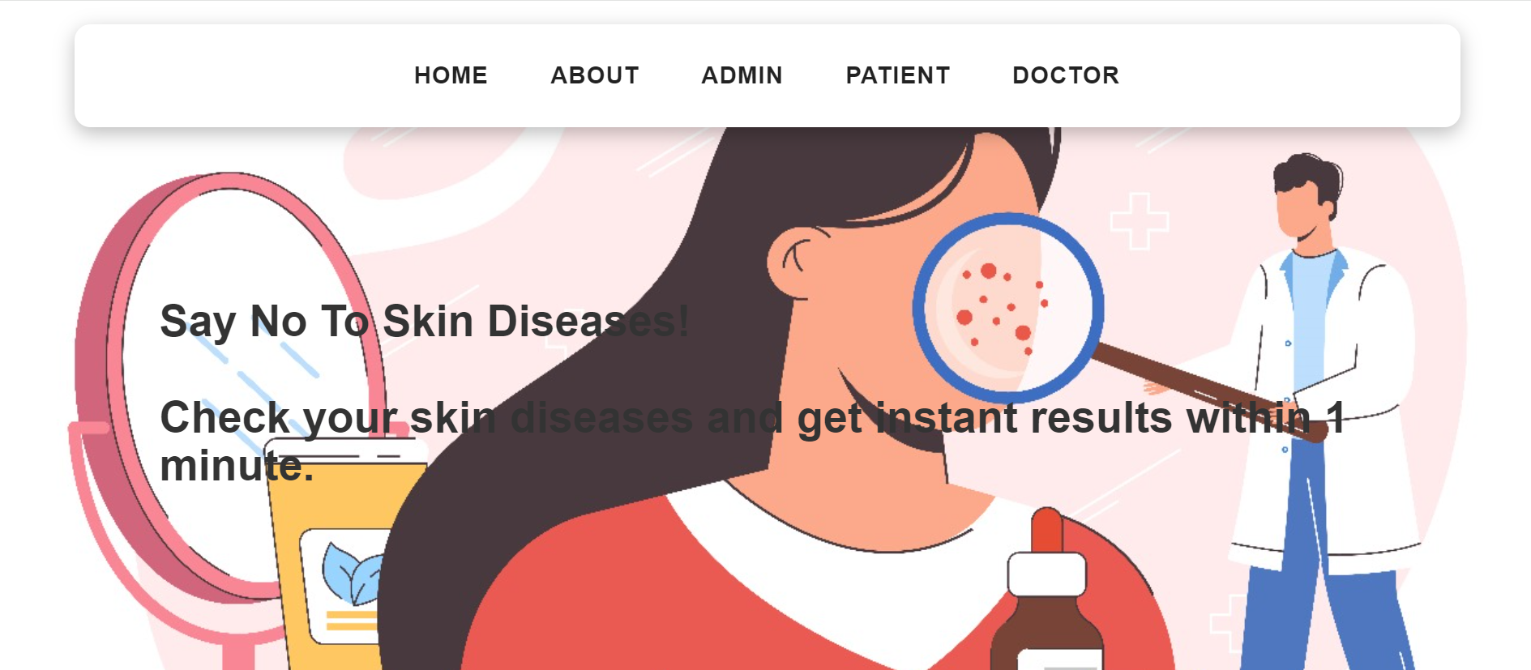

**Step-2: User Registration and Authentication**

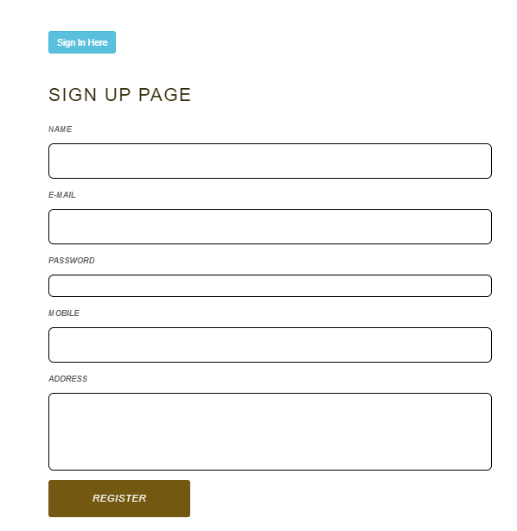



**Step-3: Image Upload and Data Input**

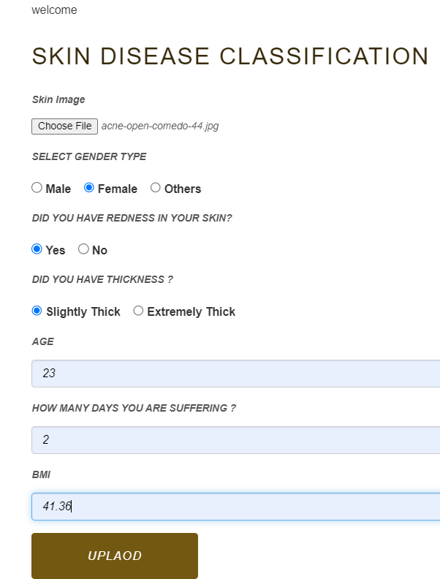

**Step-4:** **Diagnostic Report Generation**

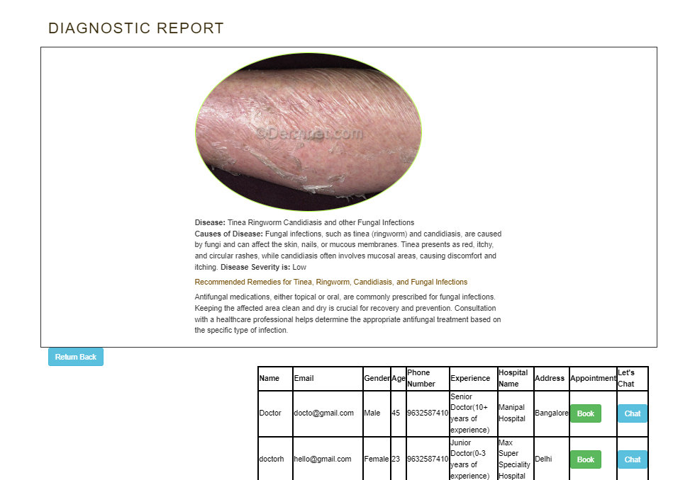

**CHAPTER 6**

**CONCLUSION AND FUTURE SCOPE**

**CONCLUSION**

The conclusion of this project, centered around the development of a ResNet50 model for dermatological image classification, encapsulates both the achievements and challenges encountered in this innovative endeavor. The project aimed to leverage the strengths of convolutional neural networks to create a powerful tool for diagnosing skin conditions, and while it demonstrated potential, the results also highlighted key areas for improvement.

The model's ability to progressively learn and improve its accuracy over training epochs is a testament to the viability of ResNet50 for image classification tasks.

However, the project also encountered challenges, most notably in the model's moderate accuracy and its lower precision and recall values. These issues underscore the complexity of skin disease classification and the need for a more robust training dataset that encompasses a greater diversity of skin types, conditions, and stages of diseases. Additionally, the model's performance discrepancy between the training and validation phases indicates a tendency towards overfitting, suggesting a need for better generalization techniques.

In conclusion, this project lays the groundwork for future research in AI-driven dermatological diagnostics. It underscores the potential of hybrid AI models in healthcare but also highlights the critical importance of comprehensive data and advanced training methodologies. Future efforts should focus on refining the model to better capture the diverse manifestations of skin conditions, ultimately leading to a tool that is both highly accurate and reliable in a clinical setting.

**FUTURE SCOPE**

The future scope of this project, focusing on AI-driven dermatological diagnostics using a ResNet50 model, is both promising and expansive. One key area for development is enhancing the model's accuracy and generalizability. This can be achieved by expanding the training dataset with more diverse images, representing a wider range of skin conditions, types, and ethnicities. Implementing advanced data augmentation techniques can also improve the model's ability to handle real-world variability in skin images.

Another potential direction is the integration of additional data types, such as patient history or demographic information, to complement the image-based diagnosis. This could lead to more personalized and accurate assessments.

Furthermore, exploring the deployment of this model in telemedicine and mobile health applications could significantly broaden access to dermatological care, particularly in underserved regions. Finally, continuous advancements in AI and machine learning provide opportunities to further refine the model, exploring newer architectures and training techniques to enhance performance and efficiency. These efforts will collectively drive the evolution of AI in dermatology, making it an indispensable tool in modern healthcare.

**CHAPTER 7**

**REFERENCES**

|  |  |
| --- | --- |
| [1] | D. Z. Li, "Artificial Intelligence in Dermatology Image Analysis: Current Developments and Future Trends," 2022. |
| [2] | A. Esteva, "Dermatologist-level classification of skin cancer with deep neural networks," 2017. |
| [3] | Y. e. al, "Automated Melanoma Recognition in Dermoscopy Images via Very Deep Residual Networks," *IEEE,* pp. 994 - 1004, 2016. |
| [4] | Apalla, "Delayed skin cancer diagnosis in 2020 because of the COVID-19-related restrictions: Data from an institutional registry," 2021. |
| [5] | "Melanoma Detection by Analysis of Clinical Images Using Convolutional Neural Network," *IEEE,* 2020. |
| [6] | Chollet and François, "Deep Learning with Depthwise Separable Convolutions". |
| [7] | X. Z. S. R. S. Kaiming He, "Deep Residual Learning for Image Recognition," 2015. |
| [8] | I. K. Ayda Acarcorresponding, "Comparison of Actinic Keratosis and Severity Index with Physician Global Assessment and Total Lesion Count and the Ability to Predict Skin Cancer". |
| [9] | R. Suganya, "An automated computer aided diagnosis of skin lesions detection and classification for dermoscopy images," *IEEE,* 2016. |
| [10] | M. N. Alam, T. T. K. Munia, K. Tavakolian and F. Vasefi, "Automatic detection and severity measurement of eczema using image processing," *IEEE,* 2016. |
| [11] | Zisserman, "Very Deep Convolutional Networks for Large-Scale Image Recognition," 2014. |
| [12] | M. G. K. A. F. M. A. A. H. Y. M. Shamsul Arifin, "Dermatological disease diagnosis using color-skin images," *IEEE,* 2012. |
| [13] | M. A. R. N. A. Rahat Yasir, "Dermatological disease detection using image processing and artificial neural network," *IEEE,* 2015. |
| [14] | M. Dildar, S. Akram, M. Irfan, H. Khan, M. Ramzan, A. Mahmood, S. Alsaiari, A. Saeed, M. Alraddadi and M. Mahnashi, "Skin Cancer Detection: A Review Using Deep Learning Techniques," 2012. |
| [15] | B. Widrow and M. Lehr, "30 years of adaptive neural networks: perceptron, Madaline, and backpropagation," *IEEE.* |
| [16] | A. Krizhevsky, I. Sutskever and G. E. Hinton, "ImageNet Classification with Deep Convolutional," 2012. |
| [17] | ALEnezi and N. S. ALKolifi, *A Method Of Skin Disease Detection Using Image Processing And Machine Learning,* p. 8, 2019. |
| [18] | Antkowiak and Michal, "Artificial Neural Networks vs. Support Vector Machines for Skin Diseases Recognition," *Google Scholar,* 2006. |
| [19] | N. Gessert, M. Nielsen, M. Shaikh, R. Werner and A. Schlaefer, "Skin lesion classification using ensembles of multi-resolution EfficientNets with meta data," 2020. |
| [20] | B. P. Saradhi, K. G. R. Narayan and T. S. Chakravarthy, "Analysis on Characteristics and Efficiency in," *International Journal of Engineering and Advanced Technology (IJEAT),* 2019. |

**APPENDIX**

**Conference Presentation Certificate**



